|  |
| --- |
| Puneet Sir and Shrenik Jain |
| **Linear Algebra Practice** |
| PYQ’s |

|  |
| --- |
| VARUN KUMAR |

Table of Contents

[**Puneet Sir** 2](#_Toc200912861)

[**Shrenik Jain Sir** 3](#_Toc200912862)

[Lecture 01 3](#_Toc200912863)

[Lecture 02 8](#_Toc200912864)

[Lecture 03 12](#_Toc200912865)

# **Puneet Sir – Self Question**

# **Shrenik Jain Sir – PYQ’s Practice**

## Lecture 01

Ink Drawings
The rank of the matrix ﷐﷐﷐𝟓﷮𝟎﷮𝟎﷮𝟐﷯﷮﷐−𝟓﷮𝟎﷮𝟎﷮𝟏﷯﷮﷐−𝟓﷮𝟎﷮𝟎﷮𝟏﷯﷮﷐𝟓﷮𝟎﷮𝟎﷮𝟐﷯﷯﷯ is
2
3
4
1
[GATE 2021 | CS]
﷐﷐﷐𝟓﷮𝟎﷮𝟎﷮𝟐﷯﷮﷐−𝟓﷮𝟎﷮𝟎﷮𝟏﷯﷮﷐−𝟓﷮𝟎﷮𝟎﷮𝟏﷯﷮﷐𝟓﷮𝟎﷮𝟎﷮𝟐﷯﷯﷯
Ink Drawings
Ink Drawings
Ink Drawings
Ink Drawings
Ink Drawings
Ink Drawings
Ink Drawings
Ink Drawings
Ink Drawings
Ink Drawings
Ink Drawings
Ink Drawings
Ink Drawings
Ink Drawings
Ink Drawings
﷐﷐﷐𝟓﷮𝟎﷮𝟎﷮𝟐﷯﷮﷐−𝟓﷮𝟎﷮𝟎﷮𝟏﷯﷮﷐𝟎﷮𝟎﷮𝟎﷮𝟏﷯﷮﷐𝟎﷮𝟎﷮𝟎﷮𝟐﷯﷯﷯
Ink Drawings
Ink Drawings
Ink Drawings
Ink Drawings
Ink Drawings
Ink Drawings
Ink Drawings
Ink Drawings
Ink Drawings
Ink Drawings
Ink Drawings
Ink Drawings
Ink Drawings
Ink Drawings
Ink Drawings
Ink Drawings
Ink Drawings
Ink Drawings
Ink Drawings
Ink Drawings
Ink Drawings
Ink Drawings
Ink Drawings
Ink Drawings


Ink Drawings
Ink Drawings
Ink Drawings
Ink Drawings
Ink Drawings
Ink Drawings
Ink Drawings
Ink Drawings
Ink Drawings
Ink Drawings
Ink Drawings
Ink Drawings
Ink Drawings
Ink Drawings
Ink Drawings
Ink Drawings
Ink Drawings
Ink Drawings
Ink Drawings
Ink Drawings
Ink Drawings
Ink Drawings
Ink Drawings
Ink Drawings
Ink Drawings
Ink Drawings
If A is a square matrix then orthogonally property mandates
AAT = A-1
AAT = A2
AAT = 0
AAT = I
[GATE 2021 | CE]


Ink Drawings
Ink Drawings
Ink Drawings
Ink Drawings
Ink Drawings
Ink Drawings
Ink Drawings
Ink Drawings
Ink Drawings
Ink Drawings
Ink Drawings
Ink Drawings
Ink Drawings
Ink Drawings
Consider a nxn matrix A and a non-zero nx1 vector P. Their product AP = ﷐𝜶﷮𝟐﷯P, Where 𝜶 ∈ ℝ and . Based on given information, the Eigen Value of A2 is:
𝜶
﷐𝜶﷮𝟐﷯
﷐𝜶﷮𝟒﷯
﷐﷮𝜶﷯
[GATE 2021 | ME]
Ink Drawings
Ink Drawings
Ink Drawings
Ink Drawings
Ink Drawings
Ink Drawings
Ink Drawings
Ink Drawings
Ink Drawings
Ink Drawings
Ink Drawings
Ink Drawings
Ink Drawings
Ink Drawings
Ink Drawings
Ink Drawings
Ink Drawings
Ink Drawings
Ink Drawings
Ink Drawings
Ink Drawings
Ink Drawings
Ink Drawings
Ink Drawings
Ink Drawings
Ink Drawings
Ink Drawings
Ink Drawings
Ink Drawings
Ink Drawings
Ink Drawings
Ink Drawings
Ink Drawings
Ink Drawings
Ink Drawings
Ink Drawings
Ink Drawings
Ink Drawings
Ink Drawings
Ink Drawings
Ink Drawings
Ink Drawings
Ink Drawings
Ink Drawings
Ink Drawings
Ink Drawings
Ink Drawings
Ink Drawings
Ink Drawings
Ink Drawings
Ink Drawings
Ink Drawings
Ink Drawings
Ink Drawings
Ink Drawings
Ink Drawings
Ink Drawings
Ink Drawings
Ink Drawings
Ink Drawings
Ink Drawings


Ink Drawings
Ink Drawings
Ink Drawings
Ink Drawings
Ink Drawings
Ink Drawings
Ink Drawings
Ink Drawings
Ink Drawings
Ink Drawings
Ink Drawings
Ink Drawings
Ink Drawings
Ink Drawings
Ink Drawings
Ink Drawings
Ink Drawings
Ink Drawings
Ink Drawings
Ink Drawings
Ink Drawings
Ink Drawings
Ink Drawings
Ink Drawings
Ink Drawings
Ink Drawings
Ink Drawings
Ink Drawings
Ink Drawings
Ink Drawings
Ink Drawings
Ink Drawings
Ink Drawings
Ink Drawings
Ink Drawings
Ink Drawings
Ink Drawings
Ink Drawings
If P = ﷐﷐1﷮2﷮3﷮4﷯﷯ and Q = ﷐﷐0﷮1﷮1﷮0﷯﷯  then QT PT is

﷐﷐1﷮2﷮3﷮4﷯﷯ 

﷐﷐1﷮3﷮2﷮4﷯﷯ 

﷐﷐2﷮1﷮4﷮3﷯﷯ 

﷐﷐2﷮4﷮1﷮3﷯﷯ 
[GATE 2021 | CE]
Ink Drawings
Ink Drawings
Ink Drawings
Ink Drawings
Ink Drawings
Ink Drawings
Ink Drawings
Ink Drawings


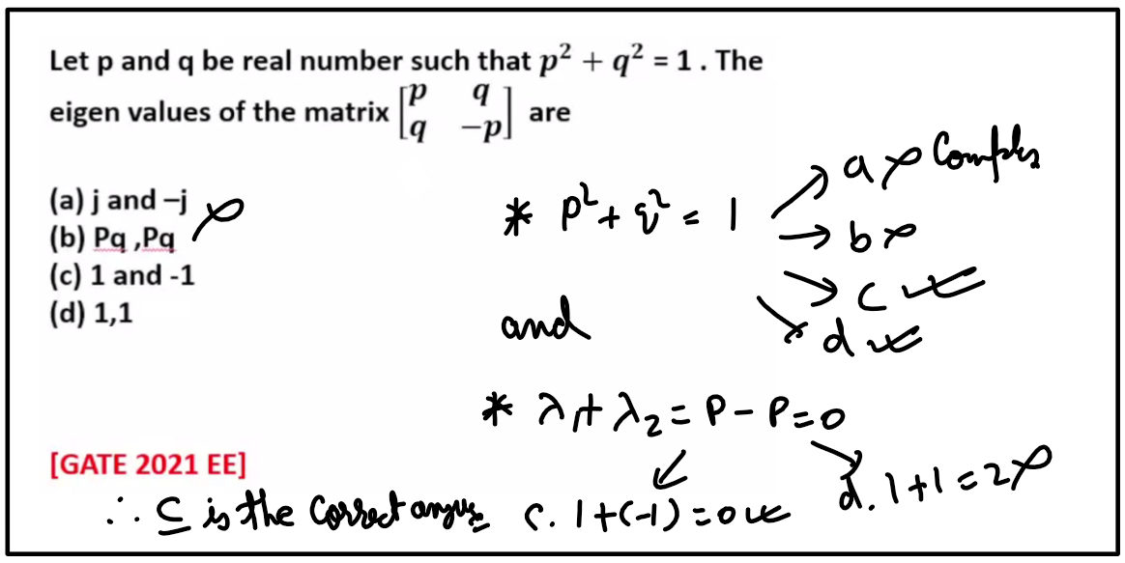

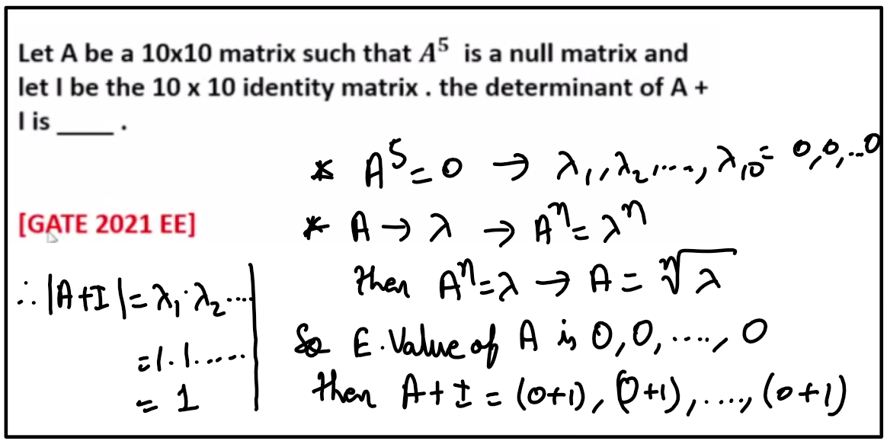

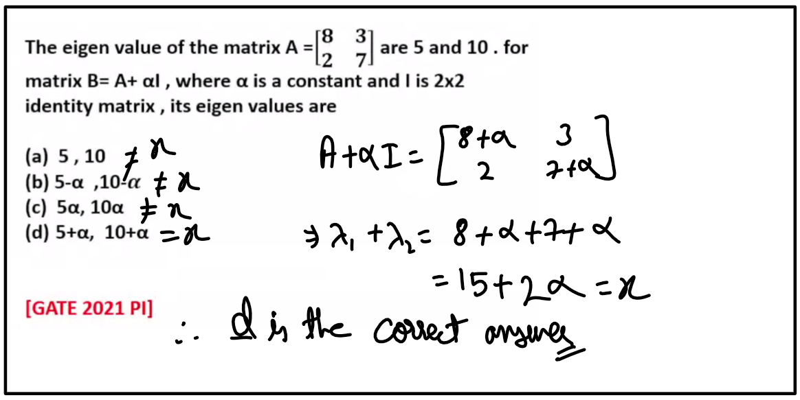

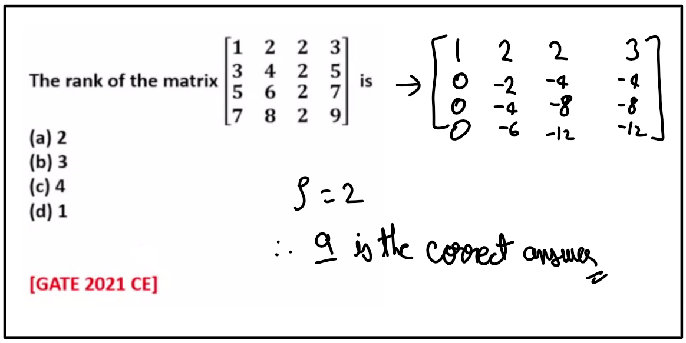

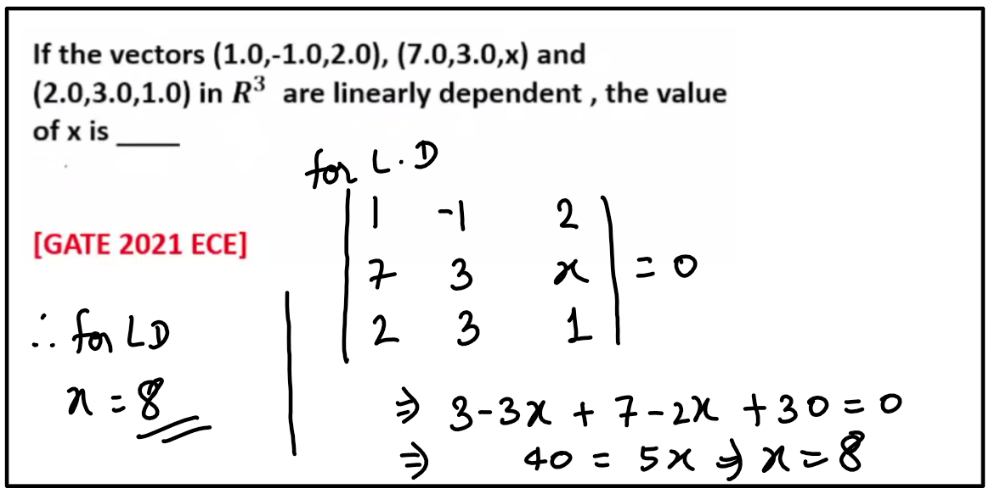

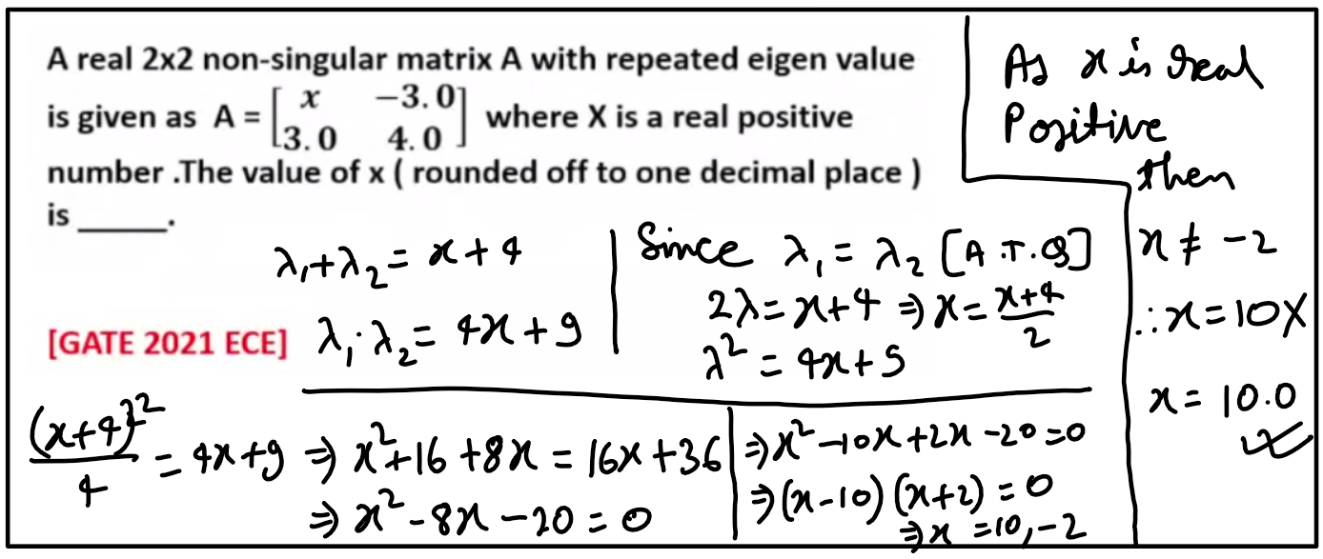

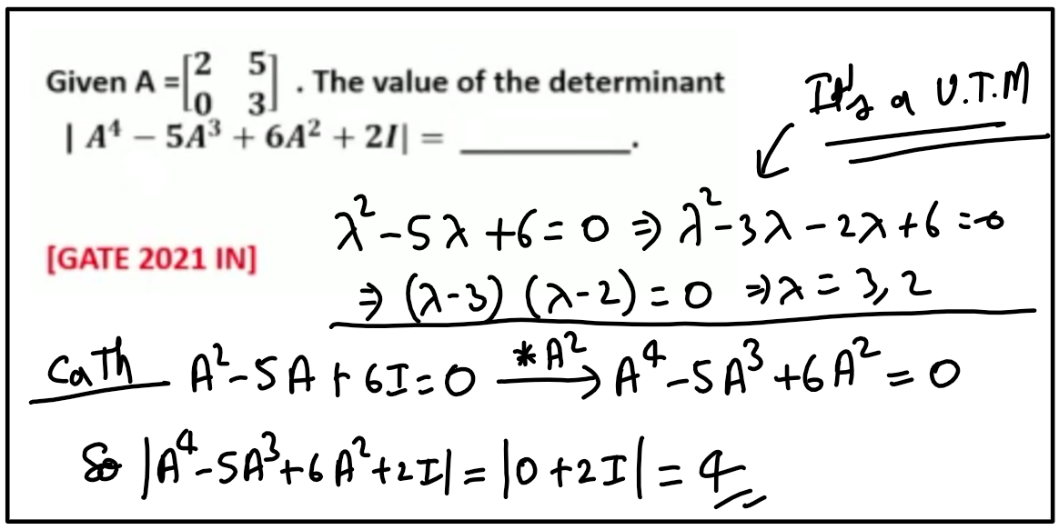

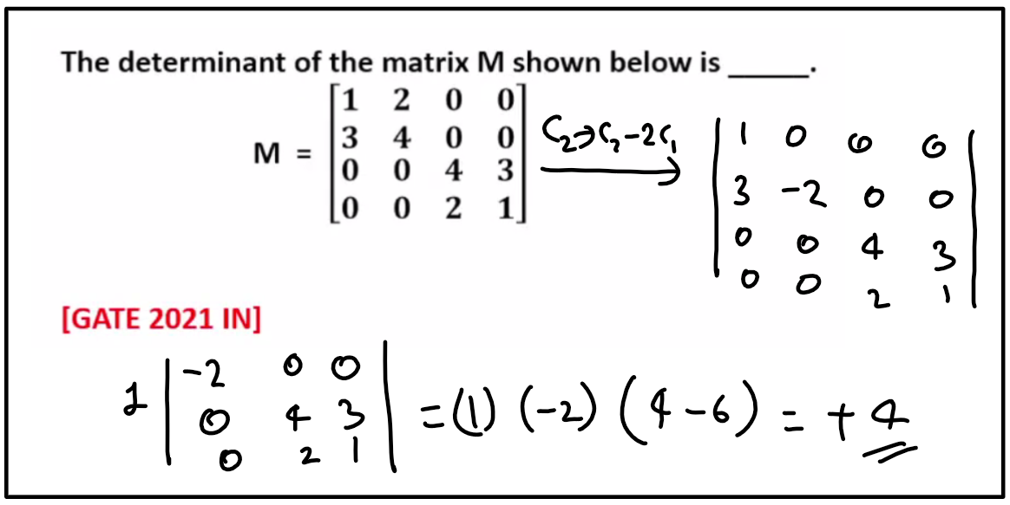

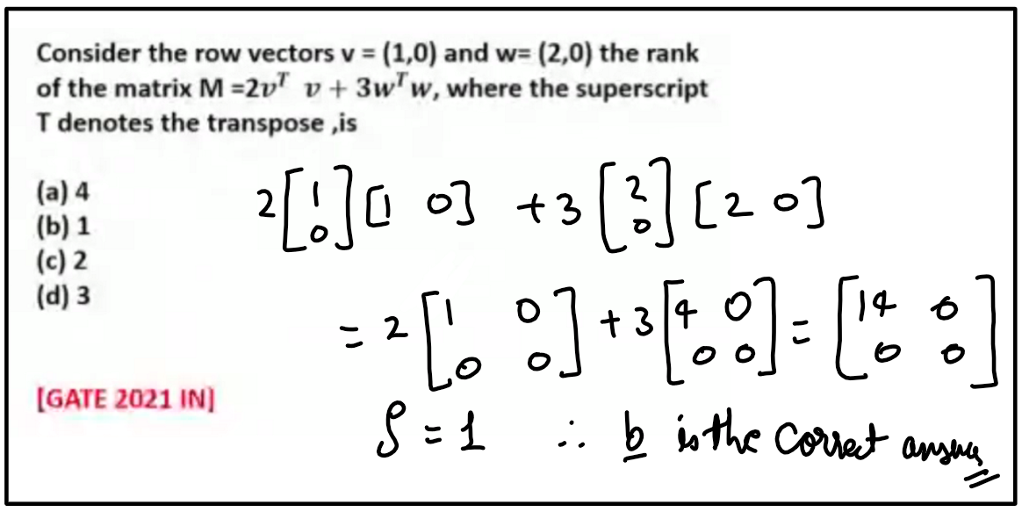

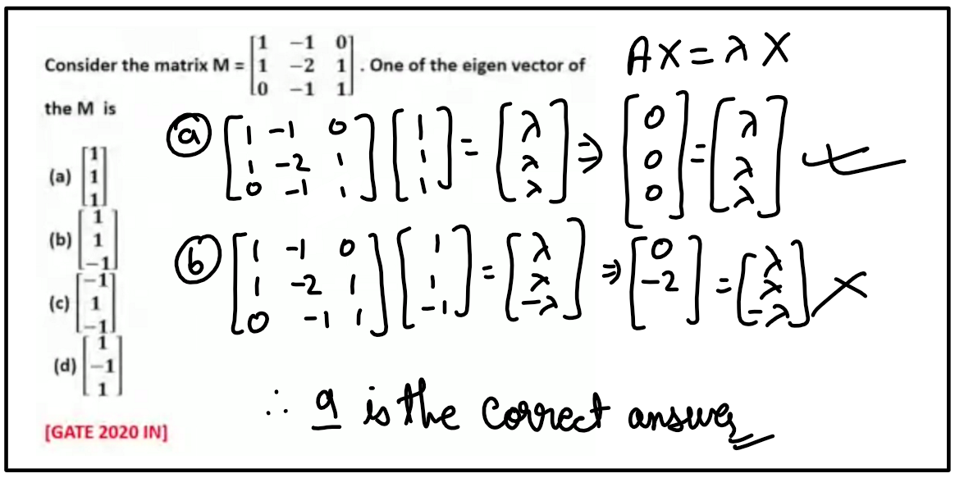

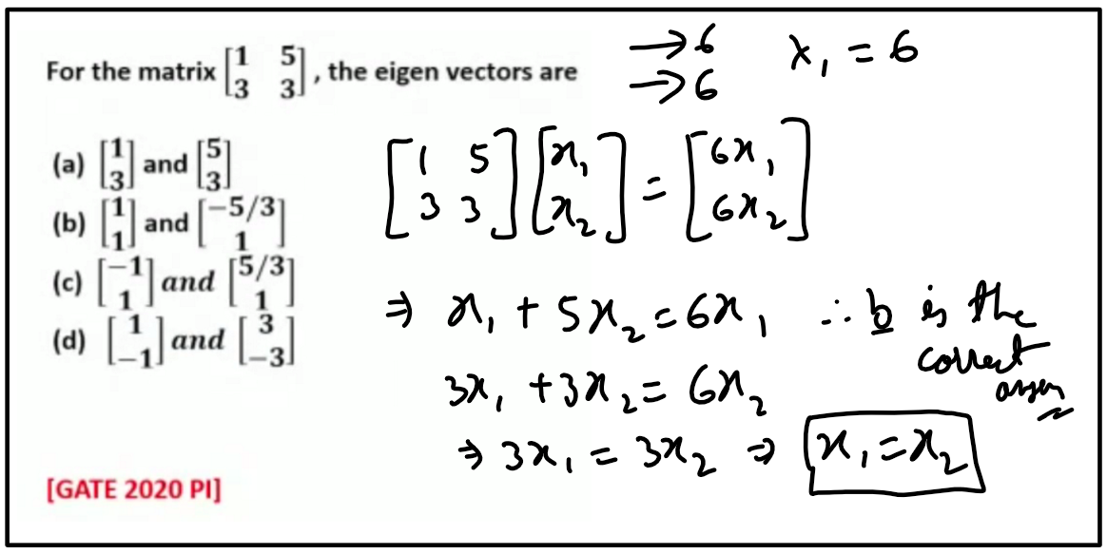

## Lecture 02

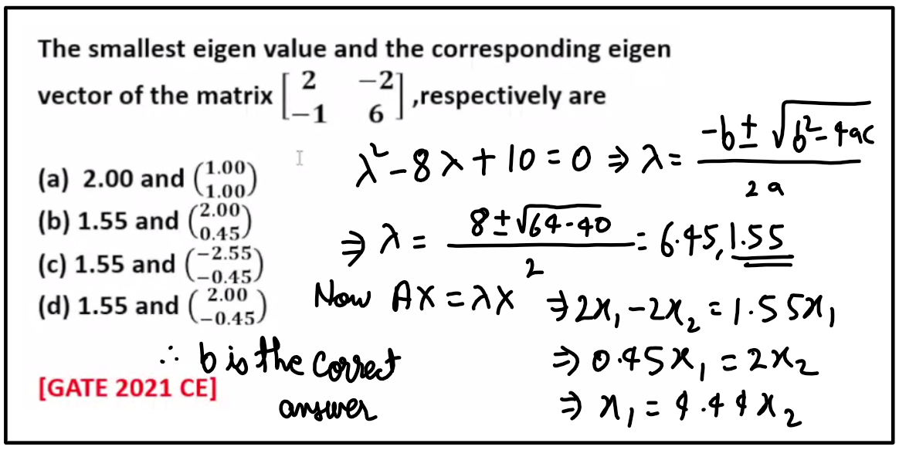

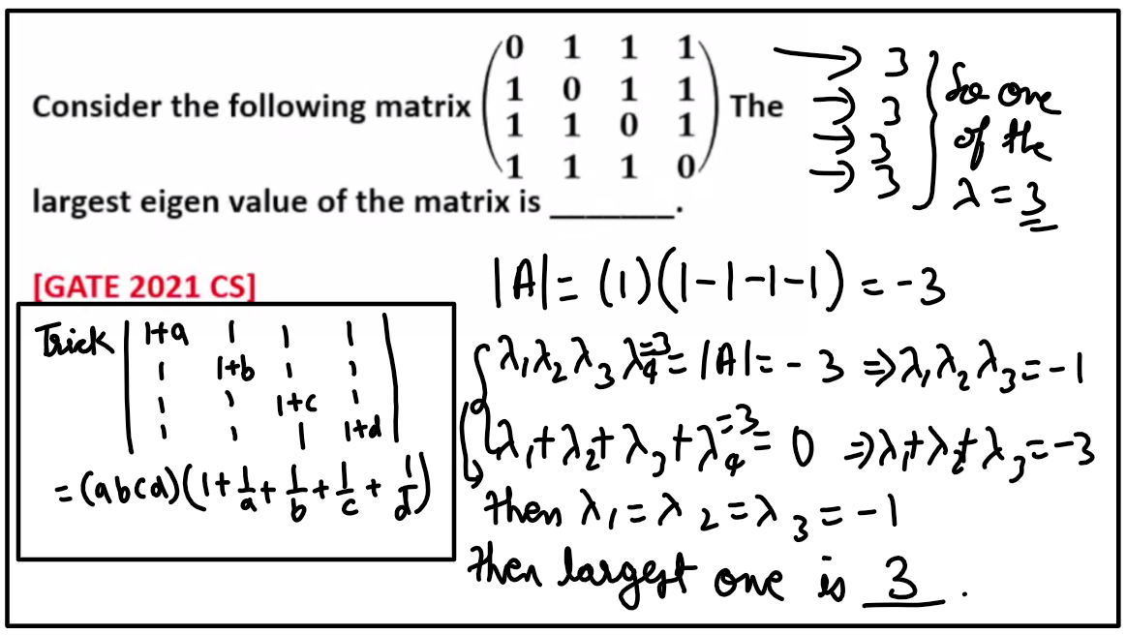

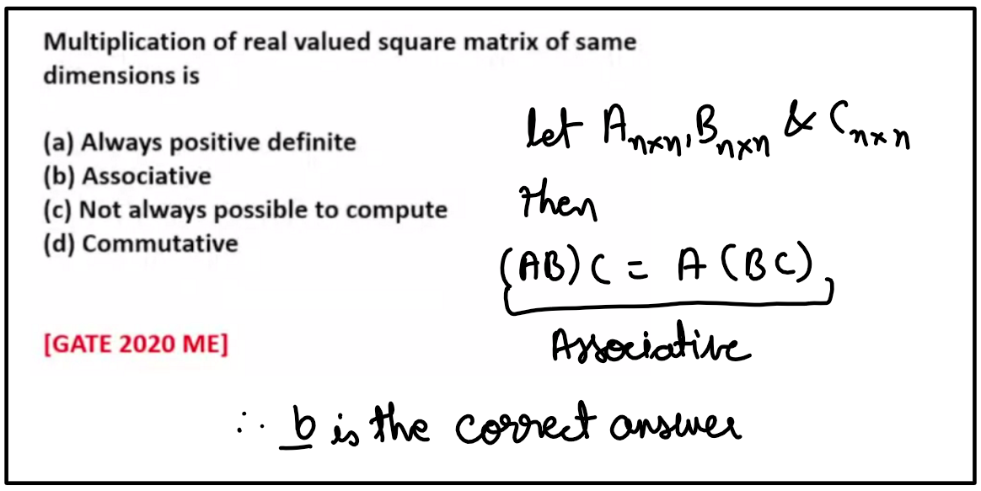

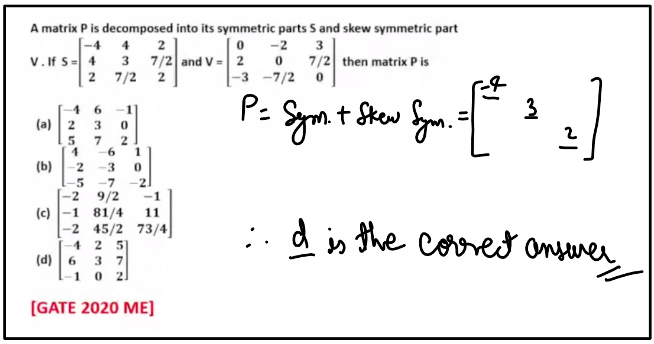

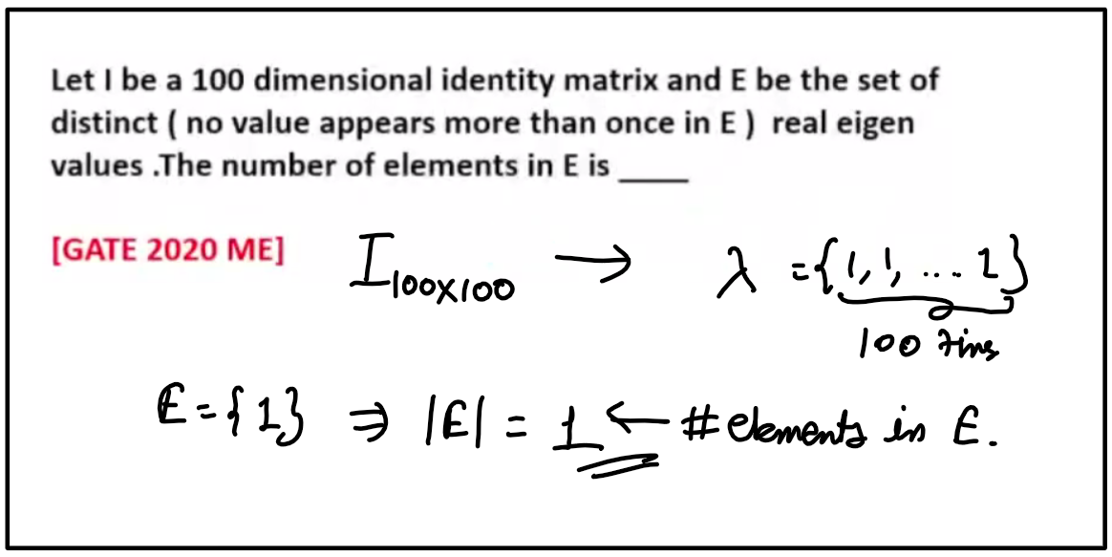

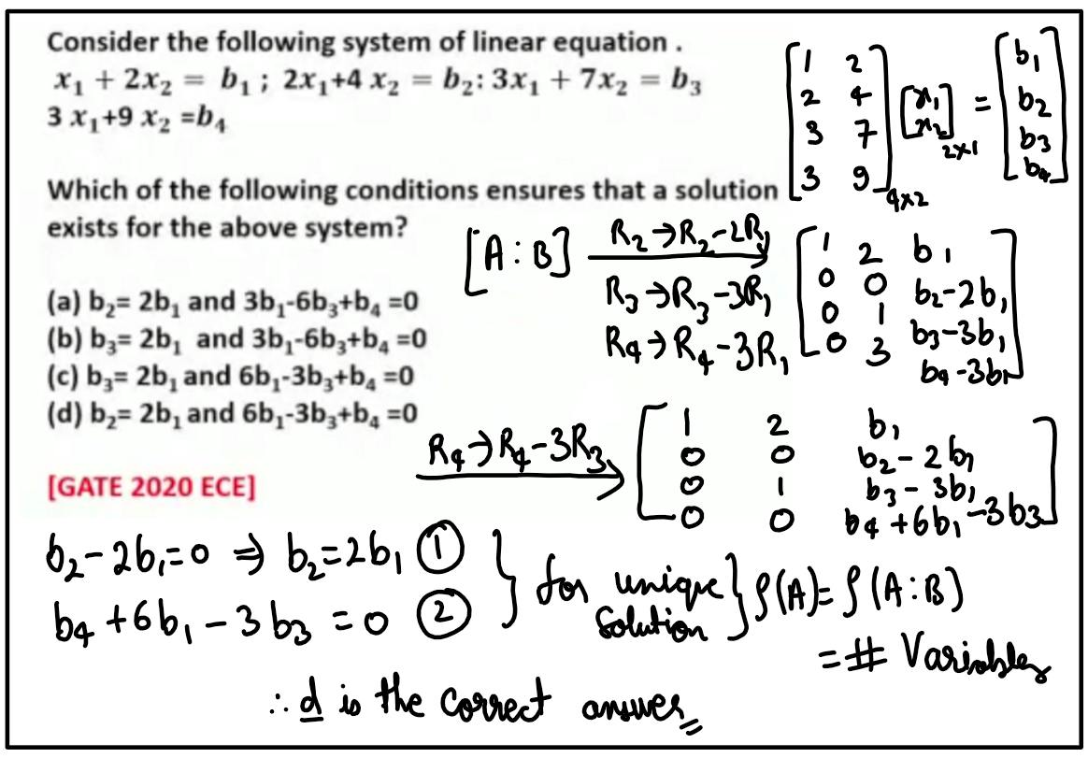

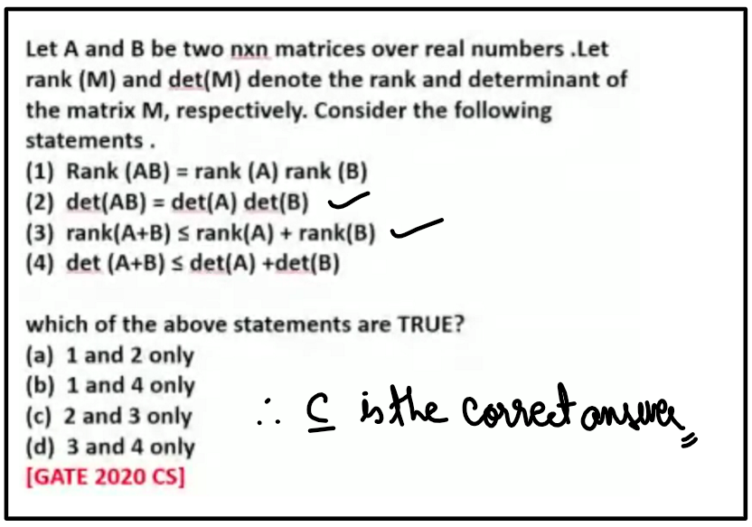

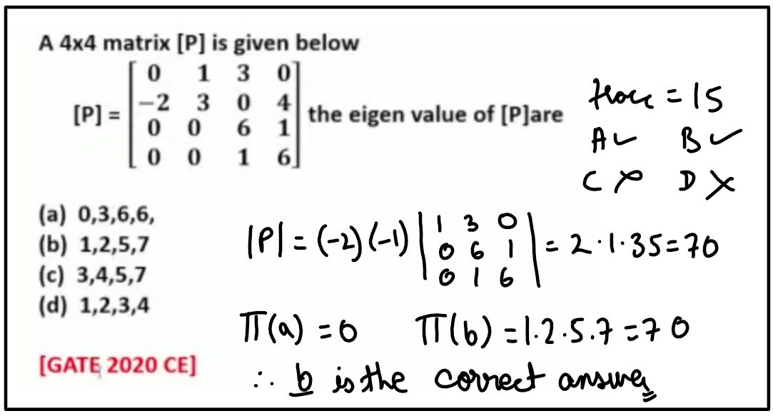

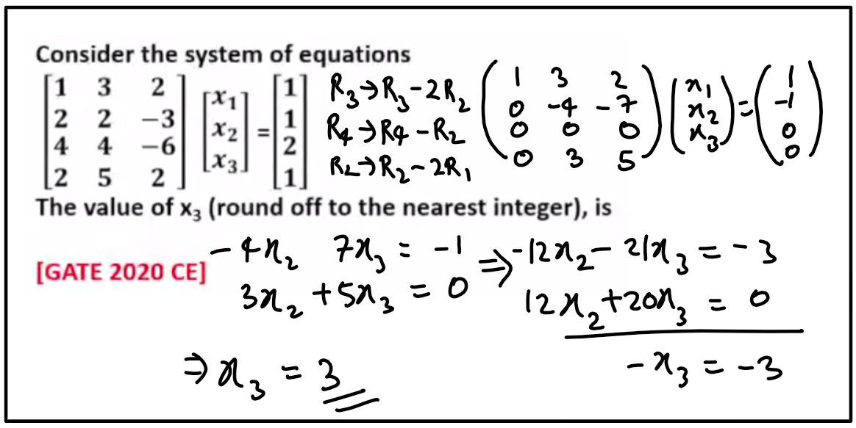

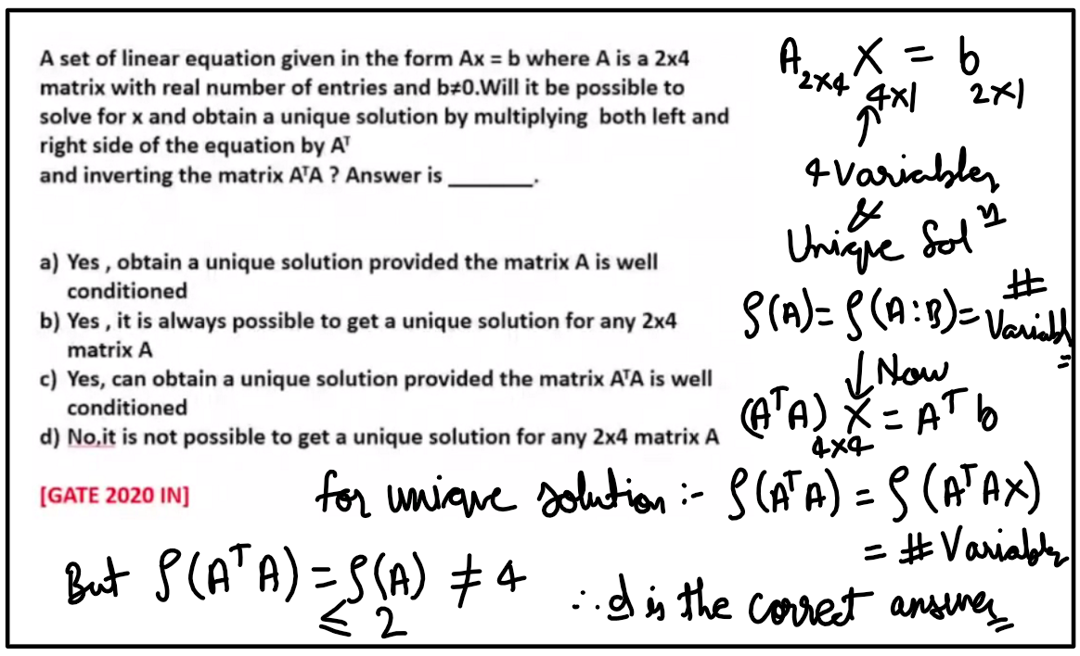

## Lecture 03